Chocolate boxes
Design as many boxes as you can that can hold 36 chocolates (each of which is a small cube).
Is there a design that uses the least amount of paper to cover all the sides? How can you be sure that your answer is correct?
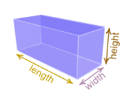
Design one
Dimensions of the box Total surface area of the box

Design two
Dimensions of the box Total surface area of the box

Design three
Dimensions of the box Total surface area of the box

Design four
Dimensions of the box Total surface area of the box

Design five
Dimensions of the box Total surface area of the box

Design six
Dimensions of the box Total surface area of the box

