2, 4, 8

Background Information

*** | This background information should be read before attempting the task with staff but should not be information given to staff as it will give too much of the intent of the task away, the idea is for them to come to some of the conclusions outlined below. | ***

This video produced by a Youtube content creator called Derek Muller, he runs a channel called Veritasium that has a lot of great videos. Although not designed to examine executive functions this video is predominantly looks at ideas of impulse control and flexible thinking and the full video can be found at this link.

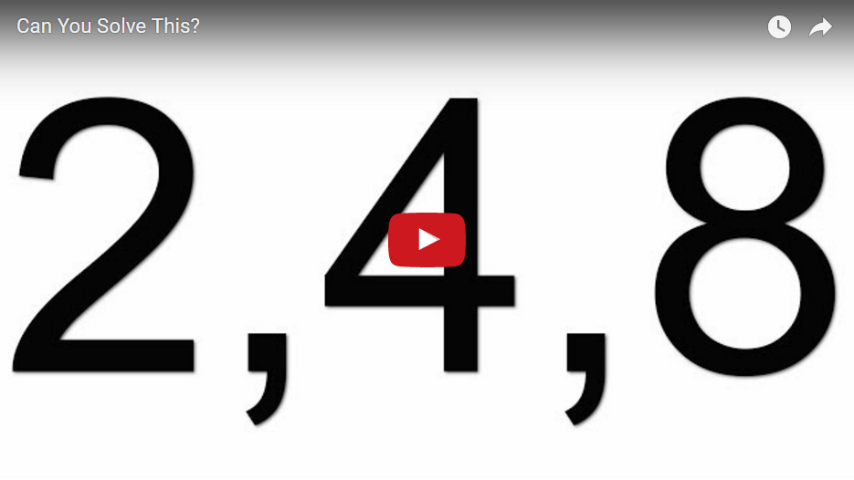

This video is very strong in looking at the executive functions of cognitive flexibility and impulse control. It is a great one to do with staff as they can really engage in what it feels like when these executive functions are being challenged. What I also like is that most people’s experience with this problem is the same as that of the people in the video. Most people when they think they have figured out the pattern continue only to propose numbers that fit that pattern despite being given information to refute that rule. They get stuck on that pattern they have seen, the brain is wired to pick up these patterns.
In working with this task with staff it is really important that you don’t help them with it, you need to exercise your own impulse control, don’t propose numbers that do fit the rule, don’t propose numbers that don’t fit the rule, this will hint to where you are thinking they should head.

Implementation Advice

To implement this task in a training environment for staff you will need access to
- a internet connected computer
- projector
- speakers.
You will also want teachers in groups so that you can have them discussing the questions. The activity can be found at the following link

http://empoweringlocallearners.weebly.com/2-4-8-activity.html
Ensure you scroll down so that the video and the questions are visible on the screen. Section 1 means that it is the first video with the attached questions, section 2 is the second video etc

  - SECTION 1
In looking at the first activity for this workshop you need to be very clear of your role in the activity. Your only responses to the sets of numbers they propose are either “Those numbers fit my rule” or “Those numbers do not fit my rule”. The rule they are trying to uncover is
NUMBERS IN ASCENDING ORDER
Some sets of numbers that do and do not fit the rule is below. Do not give these as suggestions during the activity
Fits the rule | Does not fit the rule
2, 4, 8  1, 2, 3  1, 7, 10  4, 17, 1042 | 10, 9, 8  6, 9, 2  100, 98, 96  5, 1, 12

To give a clear idea of how you should run this part of the activity watch the whole video – link in the background information, it is really important that you do not give any information away. Give them a few minutes to pose numbers and rules

  - SECTION 2
Let them know that this section on of the video deals with their initial responses of the people talked to in producing this video. They need to look for similarities and differences and think about possible reasons for these
- Play the video
- Give them time in groups to think about the questions posed which are
  - How does this compare to your experience of the activity initially? Is it similar, is it different?
  - ​Why do you believe there is so much similarity between the respondents?
  - Is there a link to executive function?
- Get tables to share some of their responses
Further Discussion
Initially when you are getting number sequences in section 1, you will probably see the same sorts of thinking, they will latch onto the doubling idea early, because we see it early. Some groups move away from the doubling quickly some take longer. I think in many cases, even before we know the task, just seeing those numbers causes us to notice the pattern because our brains are hard-wired to recognise patterns. So it is almost a sense of “once we have seen it, we can’t un-see it”
In this section of the video there is a distinct lack of both impulse control and cognitive flexibility, they know the rule they are following is incorrect, but they keep following it anyway, this is a lack of impulse control, but this could be due to not being able to see it in any other way, a lack of cognitive flexibility.

  - SECTION 3
- Tell them that this section of the video represents a shift in their thinking as they shift away from their initial rule and towards new rules. It is a video where we can see a lot of strain in their thinking as they grapple with their executive functioning
- Play the video
- Give them time in groups to think about the question posed which is
  - Executive function features highly in this section of the video, particularly in relation to impulse control and cognitive flexibility. What evidence is there of these factors at work?
- Get some tables to share their thinking.
Further Discussion
There are some quite dramatic shifts in the types of thinking they are doing as this section of the video progresses. Initially they are just keen to quickly jump on another rule, as soon as they propose a set of numbers that don’t fit the doubling rule, they make the assumption that the rule is “anything goes”. It is almost that idea that if it isn’t their initial rule, then the rule could be anything at all, again this is really staying in that tunnel vision of the original rule.
After this point there is a section where they are thinking of new rules in their head and proposing numbers that they feel does not follow the rule, they are utterly confused as to why those number still continue to follow the rule even though they don’t believe the do. This continues to build on the idea that they are not thinking flexibly enough to see those numbers beyond the pre-determined rule they have in their head, they are thinking flexibly enough to see outside of their original rule, but not enough to see beyond that rule the have just determined, there is a lot of cognitive conflict, you can hear it in how they are talking. It is at this point that they seem to randomly fire of sets of three numbers to see if any of them will stick. They are no longer thinking about previous attempts or trying to knock out possibilities, they now just seem to hope they will stumble across the answer by chance.

  - SECTION 4
- Play the video
- Give them time in groups to think about the questions posed which are
  - What are the implications of this last section of the video for our teaching? How does it link to development of conceptual understanding?
  - How might we design learning experiences that encourage this thinking?
- Get some tables to share their thinking
Further Discussion
At the start of this section of the video it was important to see how the random guessing led the woman in the video to doubt her ability to solve the problem, she had exhausted all of her rule and fell into the idea that the task cannot be done. It was interesting to see the shift in her thinking immediately when a set of numbers was proposed that did not follow the rule. In that moment her thinking snapped sharply into focus and she was able to decode what made that number set different to the rest. This may have happened so quickly because they were unconsciously following the rule all along, so it stood out when the numbers didn’t follow the rule

In relation to the development of conceptual understanding the type of thinking he talks about in his monologue at the end really plays an important part in the flexibility with which they develop conceptual understanding. The idea of only seeing white swans leading to the understanding that only white swans exist might seem strange but also is present in a lot of kids learning. If they only see a task, a concept in one way, and they are only exposed to that way over and over, then it is hard for them to see that there is any other way of looking at it, so when the nature of the task or the thinking changes even slightly it is hard for them to adjust to it, this is one of the dangers of starting at the fluency level. If kids are shown how to do it, before they have had the chance to develop the concept in a more organic way, then these breakdowns in conceptual understanding are likely to occur.What the black swan example and the 2,4,8 sequence illustrates very well is the importance of non-examples in learning, in emphasising not just the things that work, but also the things that don’t work. By unpacking what will work and what won’t work, you get a much stronger conceptual foundation for your knowledge. Section 5 will explore this further.
  - SECTION 5
Show the participants the image of the “triangles” and ask them to determine which ones children believe are triangles and which are not.
Further Discussion
When children look at these triangles they often think that the last three (blue, purple and green) are triangles but the red one isn’t. It is important to think about where that understanding comes from. Typically we will talk about triangles in relation to having 3 angles and 3 sides, which we can kind of see in all 4 of them. So the answer lies not in what we talk about, but in what we don’t talk about, if we don’t consider the straightness or connectedness of the sides then it is only giving a partial understanding. But even if all of this is considered, the question remains as to why the red one is thought not to be a triangle. Typically kids say it is because the “big part” is not at the bottom, they are judging whether it is a triangle based on its orientation. It really forces us to pay attention to how we choose to represent triangles on the materials we use, do they always look similar to the one in blue, or do we have other representations, ones like the one in red, ones that have a wide part on the side or an altitude that is not over the base etc.
Rather than telling kids about triangles it would be a lot more valuable to say that there are exactly 2 triangles on the page and have them justify to each other which ones they believe they are and why.

