How Old is the Shepherd?

Background Information

*** | This background information should be read before attempting the task with staff but should not be information given to staff as it will give too much of the intent of the task away, the idea is for them to come to some of the conclusions outlined below. | ***

This video produced by a teacher called Robert Kaplinsky in the US is one that looks closely at how students make sense, or fail to make sense, of problems the full video can be found at this link.

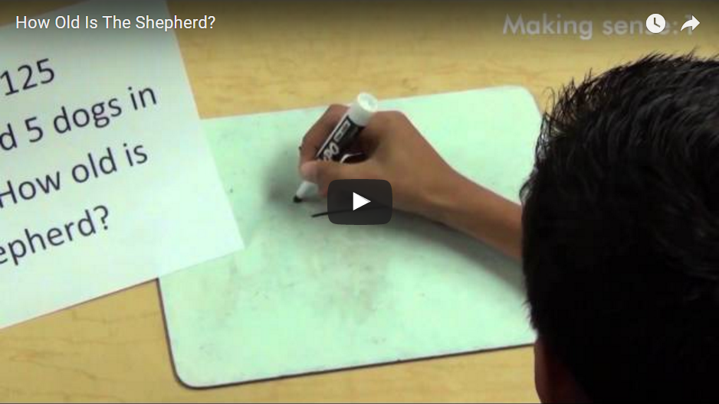

The question in the video is unsolvable, there is no way to calculate the age given the numbers there. Research has shown that 75% of kids will give a numerical answer to the problem that uses those numbers, even if the context is changed to something more familiar like “there are 125 students and 5 teachers on the oval, how old is the gardener?”
It really shows that when kids are attempting these types of tasks they are not necessarily trying to make sense of the task as a whole, they are simply looking for a starting point. They look for key terminology (as per the description of the girl in the last part of the video) and they try to do something with the numbers that are there (as shown by most who gave a numerical answer). They assumed there had to be a way to figure it out because their experience with maths previously may have been that every question has an answer that you can figure out. This also speaks to the types of tasks that we give in our classrooms. This video shows a clear break down in inhibitory control.

Implementation Advice

To implement this task in a training environment for staff you will need access to
- a internet connected computer
- projector
- speakers.
You will also want teachers in groups so that you can have them discussing the questions. The activity can be found at the following link
http://empoweringlocallearners.weebly.com/how-old-is-the-shepherd.html
Ensure you scroll down so that the video and the questions are visible on the screen. Section 1 means that it is the first video with the attached questions, section 2 is the second video etc

  - SECTION 1
- Tell the audience that they are going to first listen to a problem that they will need to make some predictions about. Emphasise that it is year 8 students solving the problem and that the task was both shown and read to them. To help put their mind at ease you may also want to mention that there is no way to possibly solve the problem given the information you have.
- Play the video
- Give them time in groups to think about the questions posed which are
  - What responses will students give to this question?
  - How many of the 32 will have accurately made sense of the problem?
- Get some tables to share their predictions
Further Discussion
From experience a lot of people say that a very high ratio (more than 50%) of their students would answer this incorrectly. After a number of groups have shared their prediction if this trend is the case then I would ask something along the lines of
“Given the responses is this a question that is too difficult for year 8’s to solve, is it something else about that question specifically or is it a broader reflection of the types of tasks that we give to students”
  - SECTION 2
Tell the audience that they are now going to be watching a video of kids solving the maths problem. Tell them to pay attention to how different kids solve the same problem, they are looking for similarities and differences. They need to try and explain how those kids are thinking about the task.
- Play the video
- Give them time in groups to think about the questions posed which are
  - Did the number of students who gave a numerical answer surprise you? Why or why not?
  - What do you notice about the student responses? Why do you feel they are answering in this way?
- Get tables to share some of their responses
Further Discussion
In looking at the responses on the video there are a few different types of responses. Those who knew there was no way to solve it, those who were able to articulate how they used the numbers given to get to an answer and ones that seemingly guessed at random.
An important discussion point is about what each of those groups of kids were thinking, those who didn’t answer it had clearly made sense of the problem, those who gave an answer with their thinking or working out had clearly not made sense of the question. However for those who seemingly wrote down a number at random it is unclear whether they actually made sense of the question or not. These students may have felt that there was no way to solve it, but also felt they had to give an answer so just wrote something down, they may have thought there was a way to solve it but had no idea how that may be so guessed, or they made sense of the problem and realised there was no answer so just predicted a value based on how old they think the shepherd should be.

  - SECTION 3
- Tell the audience that they are going to be watching a video of one of the kids who got the question wrong explaining how they got to their answer and the thinking behind why they answered in that way
- Play the video
- Give them time in groups to think about the question posed which is
  - What implications does the response of the last student have for our teaching in mathematics?
- Get some tables to share their thinking.
Further Discussion
A lot of discussion about this section generally focuses around the literacy requirements in this task. Given the task is written in front of them, and read aloud to them then my argument would be that the reading is not the problem. For me this then becomes a question as to whether it is about a problem with the student making sense of what is written on the page, or is it more an issue regarding being able to extract the relevant mathematics from the question. As the response of the last girl clearly shows they are looking for key words that point to what mathematics to use such as “sum”, “product” and “difference” and when they don’t see those have no other way to extract mathematical meaning from the sentence
This may lead to an interesting discussion around whether we should be giving these words in questions. Do these help students make sense of questions, or do they hinder students by allowing them to become too reliant on them.

  - SECTION 4
- Play the video
- Give them time in groups to think about the questions posed which are
  - What links do the three statements in this section of the video have with executive functioning?
***Staff may need a bit of a refresher on what each of the executive functions are***
- Get some tables to share their thinking
Further Discussion
In listening to the responses to this question as part of the discussion hopefully impulse control and cognitive flexibility feature heavily, but people will be more likely to see the impulse control. Impulse control becomes obvious in not “stopping and thinking” before answering the question, it lies in rushing to a response before they have fully considered the possibilities. For the first student who correctly stated that there was no way to solve it, it was clear that his impulse control was high. He did not immediately jump to saying there was no way to solve it, he knew something was wrong and that is why he said “WHAT?!” initially. But he then took the time in his own head to go through the question again verbally and try to make sense of what information was there. Impulse control was also present in the last response in being able to stop and think about what language was there and how that might help her to solve the question, but many of the wrong and random answers also indicated that lack of impulse control.
Cognitive flexibility, or a lack of it, was evident in some of the responses where it was clear they had guessed a number at random, in some instances the probably knew that there was no way to solve the problem but also did not feel there was another way to answer the problem in an appropriate manner so just guessed.

